**Becoming and Outcomes Based Organization**

This document contains six recommendations to facilitate and accelerate Molex’s success in being a high-performance organization through the adoption of Outcome-Based Thinking (OBT).

## Summary of Recommendations

**Get to Believe in Your GPS –** Although the GPS is the cornerstone tool of OBT, it’s not the map itself that is important. Instead, it is getting to the point that Molex organization establishes **trust, belief** and **reliance** to make decisions and take actions using it.

**Make Outcomes a Part of Every Employee's Daily Lexicon -** From the top of the organization to the front-line of the business, every employee should be able to recognize, articulate and personally associate themselves with one or more mission-critical outcomes.

**Be Obsessed in Achieving Outcomes -** Research confirms individuals are more motivated and engaged when challenged to achieve an outcome rather than when asked to complete a task or assignment.

**Shift from Vertical to Horizontal –** Like most companies, Molex has a dominant vertical orientation around typical business functions (i.e., Sales, Finance HR, Operations). Making a transition to an Outcome-based organization will shift this to a horizontal orientation that more accurately models the flow of business in an experience centered operating model.

**Have a Clear Line of Site -** In an outcomes-based organization a clear line of sight exists between specific tasks through the strategies and purpose of the company. Created using the GPS, this line of sight allows each employee to have a clear sense of purpose regarding their role, while they’re engaged in specific initiatives and how they contribute to the overall success of the organization.

**Foster a Nurturing Work Environment –** As roots of a tree absorb nutrients from rich soil, so do the roots of an organization gain the nourishment needed to achieve high performance from the environment in which people work. This is represented by the left portion of the GPS and is needed to be sure the trunk, branches and leaves are stony and vibrant.

## Actions to Consider

Following details specifics actions to consider in pursuing the set of aforementioned recommendations.

**Get to Believe in Your GPS**

Establishes **trust, belief** and **reliance** in OBT by using your GPS to make important operational decisions. Some suggested actions to make this happen include:

1. Create outcomes that are bold, aggressive and ideally provocative – Don’t water down outcomes to make them more comfortable or feasible in reaching. Trust the process and let your outcomes push you and your teams to places they haven’t been before. This is the genesis of transformation.
2. Keep the GPS Updated – Implement a process to make updates to the GPS so it becomes a more robust outcome-based view of the company. This will help people get acclimated to outcomes and to build confidence in using the GPS. Some suggested actions to make this happen include:
   * + Invite team members interested in the process/approach to accept accountability for updating and maintaining the GPS
     + Establish the rules and cadence for providing updates to the person or people involved in maintaining the GPS
3. Annually Reassess Molex’s Mission-Critical Priorities – Outcomes don’t change over time but those deemed most important will. Reassess which outcomes are most critical at least annually then gear your operating plans and investment portfolio accordingly.
4. Build Operational Plans and Budgets Around Outcome-Based Strategies – Doing this will avoid the pitfall of “local optimization” of functions (i.e., Sales, Operations, etc.) and instead drive “global optimization” of Molex around the GPS strategies and most important prioritized outcomes. Some suggested actions to make this happen include:
   * + Identify a team that ‘owns’ each of the relevant experience-strategies (i.e., affinity groups) and related outcomes identified on the GPS. Empower this team to determine ‘how’ to achieve their respective outcomes and peg the related performance measures.
     + Use the ideas/actions from each experience-strategy team to form a portfolio and related actions along with an operating and capital budget.
     + The leaders from each experience-strategy team work collectively to groom and optimally manage the operating portfolio and budgets.
5. Operationalize a Performance Dashboard to Measure Outcomes – Turn the GPS 90 degrees counter clockwise so the overall purpose outcome, previously the most far-right on the map is now at the top. This orientation now provides a natural framework to design and validate Molex’s performance dashboard. Decide which outcomes should and could be measured.

Using the GPS, it becomes easy to see leading and lagging relationships and those measures that should be explicit or could be implied. Try to take the approach that less is more and challenge yourself to have as few measurements as possible. Minimally, the overall purpose outcomes and those that are furthest to the right of each experience-strategy should be measurement points on the dashboard.

1. Pursue the Right Initiatives – Outcomes will help Molex more effectively manage their project portfolio by providing the means to test the alignment and contributions of individual projects. Some suggested actions to make this happen include:
   * + Measure the impact a proposed initiative will have on each of the targeted GPS outcomes. Ask the project owner and one other unbiased person to score the project against the select GPS outcomes. Assign 3-points for a high impact, 2-points for a moderate impact, 1-point for a minor impact or 0-points for no impact. Totally up the points provide an immediate indication of the value the initiative will provide Molex.
     + Compare the point values of two or more initiatives to provide a more objective basis for making a more objective decision on the disposition of the initiatives. Do this for all the active, approved and planned projects in the portfolio. Following this grooming process provide a more objective basis to understand the merits of a project and give decision-makers the confidence to say ‘no’ when they don’t support mission-critical needs/priorities

**Make Outcomes a Part of Every Employees Daily Lexicon**

From the top of the organization to the front-line of the business, every employee should be able to recognize, articulate and personally associate themselves with one or more mission-critical outcomes. Here are suggestions to make this happen:

1. Make the GPS Visible – Print out in a large format of the GPS and hang on the wall where people can see it. Send every employee a PDF version of the GPS to review.
2. Explain the GPS to every employee in the company – Cascade from the executive leaders to every level in the company, an explanation of Molex’s GPS, its outcomes and mission-critical priorities, and the Statement of Purpose.
3. Ask every employee to identify their role with one or more outcomes on the GPS - This is a simple but effective way to acclimate every employee to outcome-based thinking and help them see how their role contributes to Molex’s success. This is easily accomplished when made part of a person’s performance review.
4. Make outcomes part of the conversation – In meetings or having conversations with individuals, when appropriate ask “what outcome or outcomes are we impacting”. This is particularly important for executive and senior leaders to do this. If it’s not important at the top it won’t be important anywhere else in the company.
5. Develop and cascade V2MOM (or Molex’s equivalent) – Using the overall purpose of being the leading brand experiential company along with the eight experience strategies, develop a complete V2MOM and expectations with the ELT to be accountable for their individual and collective responsibilities for driving the performance of the company’s seven strategies.

**Create an Obsession Within all Employees to Achieve Molex’s Outcomes**

Research confirms individuals are more motivated and engaged when challenged to achieve an outcome rather than when asked to complete a task or assignment. Rally the organization by tapping into their inherent capabilities to drive the performance of one or more of the seven strategies, mission-critical outcomes and performance metrics. To make this happen, consider the following suggestions:

1. Establish a Reward/Recognition Program (i.e., badges) for Success in Driving Outcomes – Accentuate the importance of outcomes by acknowledging those employees that stand out in their contributions in helping drive the strategic and mission-critical outcomes for the business.
2. Communicate on the Progress/Success in Achieving Outcomes – Take advantage of the Hawthorne Effect and shine a bright light on critical outcomes by (1) making dashboard measures visible to everyone and (2) ensuring each employee can personally relate to a critical outcome and how their role and contributions are making a difference in realizing those outcomes.

**Nurture a Culture of Innovation and Creative Problem-Solvers**

Studies in many major publications show that the next generation of companies will increasingly require communication, collaboration, and creative and critical thinking skills to be successful. The following will foster these skills at Molex:

1. Learn by solving real problems – Leverage experiential learning to strengthen employee competencies in outcomes-based thinking and innovative thinking/problem-solving by addressing real business issues.
2. Formalize Training – Deliver a structured program to complement experiential learning in developing outcomes-based thinking and innovative thinking/problem solving competencies. As part of this effort, a core team of “Master Mechanics” should be developed to be internal experts.
3. Make outcome-based thinking and innovative thinking/problem-solving a part of everyday activities – Conduct problem-solving meetings by shifting through the gears of The Mechanism™.

## Traits of High Performance

**Recognizing it’s a Journey**

More than anything, success in becoming an outcomes-based organization is a journey that has two primary dimensions. The first involves individual employees and the second is the environment in which they work.

For the individual, it begins by becoming aware and familiar with the notion of an outcomes-based organization which sparks interest and curiosity. Beyond this point and being exposed to the practices of an outcomes-based organization, the individual gains knowledge and grows into impassioned enthusiasts for what becomes possible. In time and having gained first-hand experience, the individual’s confidence in their abilities helps to create an outcomes-based organization.

Paralleling the individual’s journey are changes in the work environment that encourage and enable the realization of an outcomes-based organization. Much of this is anchored in leadership’s ability to move away from traditions and habits that perpetuate functionally dominant organizations. Much of this is the by-product of what we’ve been taught and value in terms of hierarchical organizations where an individual’s success is largely reflected in the title they carry, the fiefdoms they have built and the ‘turf’ they protect. 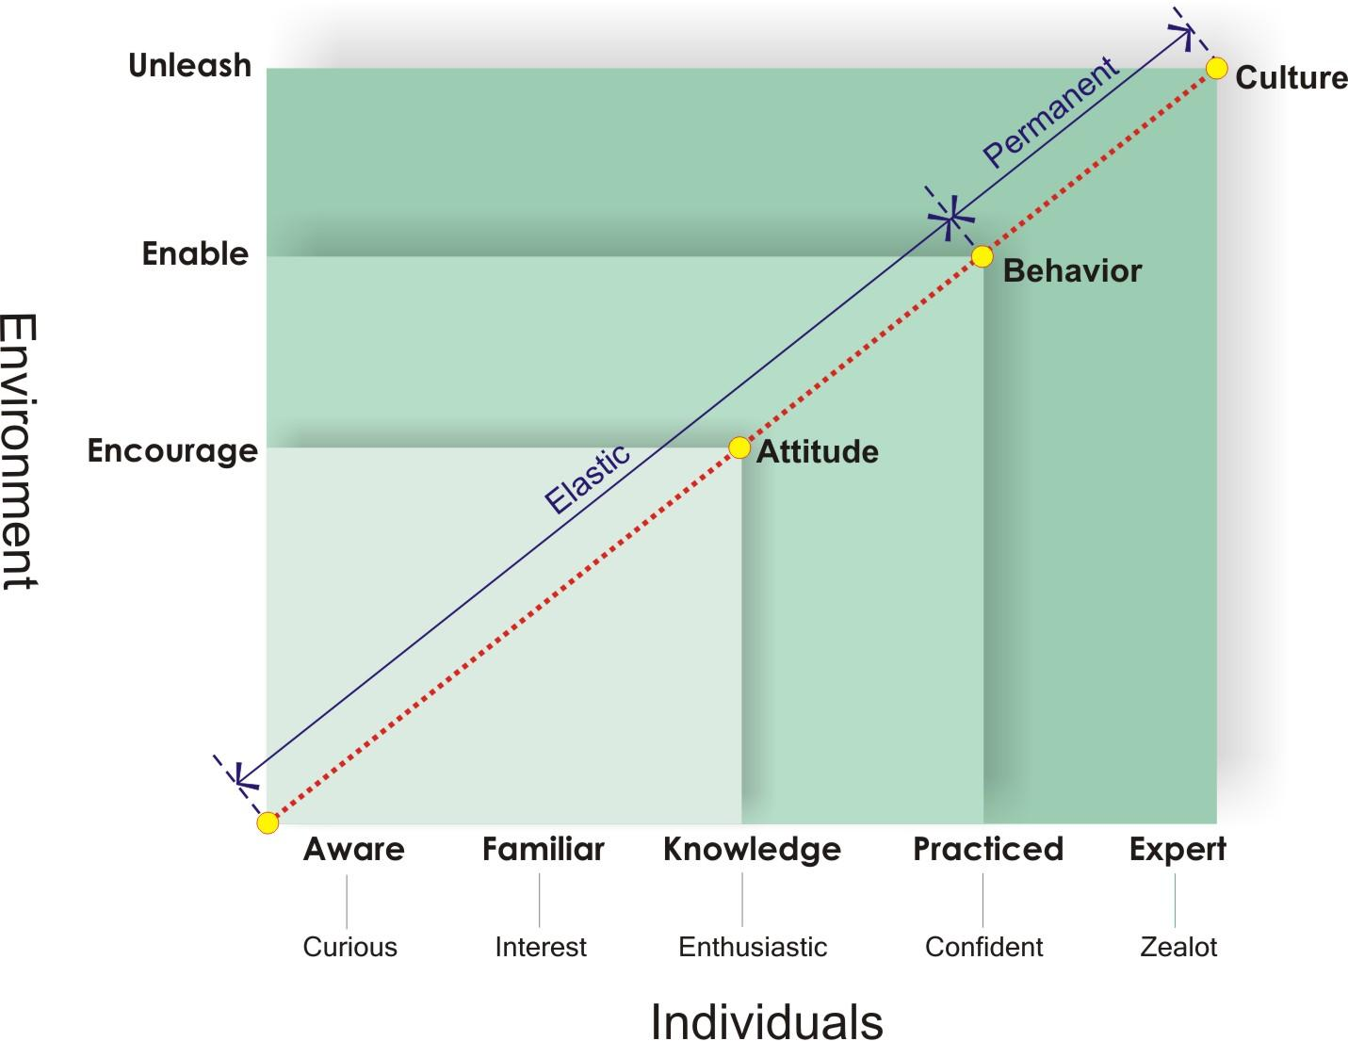

At this point the environment is enabling change in the behavior of individuals who have become well practiced and confident working in an outcomes-based organization. Attempts to change that fall short of this point, both for the individual employee and environment, result in behaviors that are elastic and like a rubber-band, snap back to their original form. Beyond this point the culture of the organization is driven to change by the zeal of individuals working in an environment that inspires, engages and enables every employee to do the extraordinary. This becomes the catalyst for sustainable advantage.

## Believing in Your GPS

It all begins with the GPS; a collection of outcomes that describe the aspirations of the organization. It’s not the GPS itself that is important, but instead the organization’s **trust, belief** and **reliance** to make decisions and take actions such as:

* Senior leaders determine the strategies and priorities for the business based on those outcomes that are critical to the mission of the company.
* Having the right resources are aligned and motivated, regardless of functional orientation, to drive and create their respective outcome.
* Ensuring outcomes become part of the common business lexicon that is used at all levels of the organization.
* Making it comfortable saying ‘no’ to pursuing an action (and making an investment of time and money) because it does not impact and materially contribute to the realization of a Mission-Critical outcome.

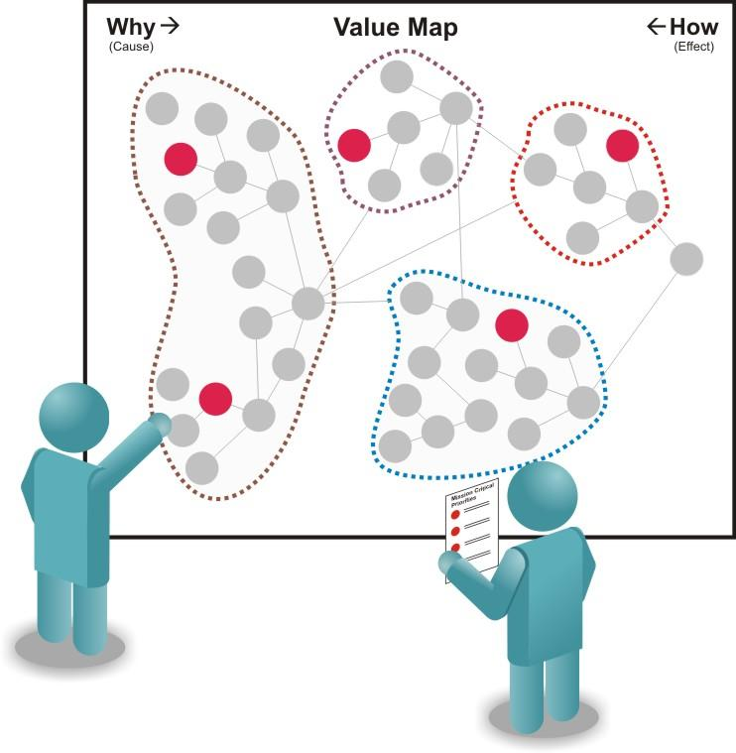

## Becoming Masters of ‘Context’

Alan Gregerman, in his book “Surrounded By Geniuses,” suggests business leaders can’t lead, not if the definition of leadership is taking a group of ordinary people and getting them to achieve extraordinary results. More often than not, leaders tend to manage rather than lead. They dwell on tactics and focus on addressing urgent and immediate issues. Furthermore, they are distracted by internal politics, and turf protection. Gregerman contends that if leaders really did their job they’d spend more time creating the context for genius to occur.

Let’s make a distinction between business content and business context. What a business does represents content, which is easy to identify simply by looking at a company’s organizational chart. Typically we’ll find a structure defined by functions or groups such as engineering, accounting, marketing, sales, operations, HR, and finance. Each of these functions reports to a single role and cascades downward to a series of subordinate roles that form the structure of the organization. It is through this hierarchical structure that content, the work that makes a business function is delivered to the marketplace.

Content also catches the attention of management and shareholders. Whether it’s a manufacturer of a service-based company, content directly transforms inputs (e.g., materials, information, knowledge) into saleable products that customers want to buy. For example, an insurance company’s content, in part, relates to the process and activities associated with developing product, sales, marketing, underwriting and claim processing.

Unlike content, business context is more difficult to identify because it represents the environment in which people work. Context is transparent and easily goes unnoticed because it disguises itself as the “normal” way of doing things in an organization. “Normal” defines how individuals operate and interact with others on a daily basis. It is a reflection of corporate culture and the legacy of how things are done. People don’t give breathing a second thought; they inhale and exhale because it’s normal. Similarly with context, people accept the day-to-day functioning of a company as being normal and do what they have historically been conditioned to do. A critical review of business context could generate some great discomfort – and tremendous opportunity.

First, the senior executives of a company are accountable for the context of their business. Where content is about managing a business context is about leading a business. Exposing aspects of context that are deficient can be uncomfortable even painful for senior business leaders. As a result, important issues to improve the environment get ignored or swept under the rug.

Second, context is more difficult to change. It reflect years of practices that form the habits and perceptions of the organization. Combine this reality with the rush for immediate decisions, actions and gratification results in a walk down the path of least resistance -- to improve content.

Finally, the discomfort with context stems from the perception that it’s not that important. Most people don’t see the correlation between context and how it drives business content. It’s not uncommon to hear the elements of context referred to as the “soft side” of the business. To illustrate this point, when justifying a capital project a typical practice for companies is to recognize and accept only ‘hard’ P&L savings, such as labor reductions, in determining the return on investment. This practice draws our attention to focus on content while dismissing context as a legitimate area of opportunity.

In mastering context the environment is created that inspires, engages and enables every employee to do, not simply their job but the extraordinary. To this end there are five strategies, 13 characteristics and 36 attributes that constitute business context.

* **Being Great Stewards of Talent and Resources**
* Employees work together as a strong and cohesive team by sharing common goals, having a clear understanding of their individual roles and having mutual respect and for each other.
* The highest degree of organizational responsiveness exists because of the ability for all employees and other resources to rally around and fluidly align to address the urgent needs of the business.
* Exhibit the discipline to ignore distractions and stay focused on the mission-critical needs of the business that support the company’s strategies and goals.
* **Having A Sense of Confidence and Personal Security**
* The well-being of employees are addressed by creating a stable work environment that recognizes the professional and personal needs of each employee and their families.
* Eliminating concerns and unnecessary distractions by demonstrating the strength, viability and solvency of the company.
* Leaders are revered and respected for their uncompromising integrity and ability to instill trust in the stakeholders of the company.
* **Taking Pride in Working for the Company**
* An impeccable set of values are demonstrated in every action that is taken by the company.
* Social consciousness and responsibility to the community is evident by helping those in need.
* **Driving Passion to Succeed**
* Appealing and exciting career opportunities exist because of deliberate planning that reflects each employee’s professional goals and desires.
* The skills and competencies of employees are continually enhanced through formal education and training as well as experiential learning.
* Success and contributions are recognized through a series of meaningfully rewards.
* Instilling self-awareness in each employee to ensure they understand the importance and value of their role contributions.
* **Effectively Setting and Managing Expectations**
* Employees have a clear sense of purpose and how their contributions benefit the company and obtainment of the key outcomes.
* Performance expectations are established and communicated so every employee knows exactly what is expected of them.
* Having continuous feedback to employees on the performance of the company and individual performance to goals and expectations.
* **Taking Timely, Confident and Accurate Decisions**
* Employees are empowered and trusted to make the right decisions.
* There is a personal sense of accountability for achieving results.
* The most valuable knowledge is easily assimilated because collaboration and the inclusion of diverse perspectives naturally occurs across the enterprise.
* There is immediate access to accurate information enabling effective communications occurs at all levels of the organization.
* **Being Curious to Explore and Create Something New**
* An innovative mindset exists in each employee.
* Employees are encouraged and supported to be innovative by making it safe to explore new ideas and having an understanding that making mistakes is essential to discovering new things.
* The process tools and techniques that foster innovative thinking are available and well-practiced.

## Organizing Around Outcomes

There is an administrative and a work component to every company. The administrative side of a business deals with personnel needs such as career development, performance reviews and the sensitive issues that require a one-to-one relationship with an employee’s manager. The work aspect deals with the activities that are needed to keep a business running and viable.

Most organizations combine the administrative and work sides of their business. Usually this occurs through the functional structure (e.g., sale, marketing, operations, engineering, etc.) of the enterprise. Work is not efficiently or effectively completed when it passes through a functional/administrative organization. There are usually competing priorities, rewards and, too often, the need to realize the optimization of each functional area. All of this consumes valuable resources in managing the inherent complexities.

Although the functional/administrative aspects are a very necessary part of any business, an outcomes-based organization naturally separates it from the work organization. In assembling teams of the appropriate competencies around an outcome, a natural work team is formed regardless of their functional/administrative orientation. Taken further and with an encouraging and enabling environment, this team is the embodiment of inclusion, collaboration, governance, empowerment and innovative thinking. More provocatively, an outcomes-based work organization has no organization. It is a collection of configurable competencies that takes form around the Mission-Critical needs of the business.

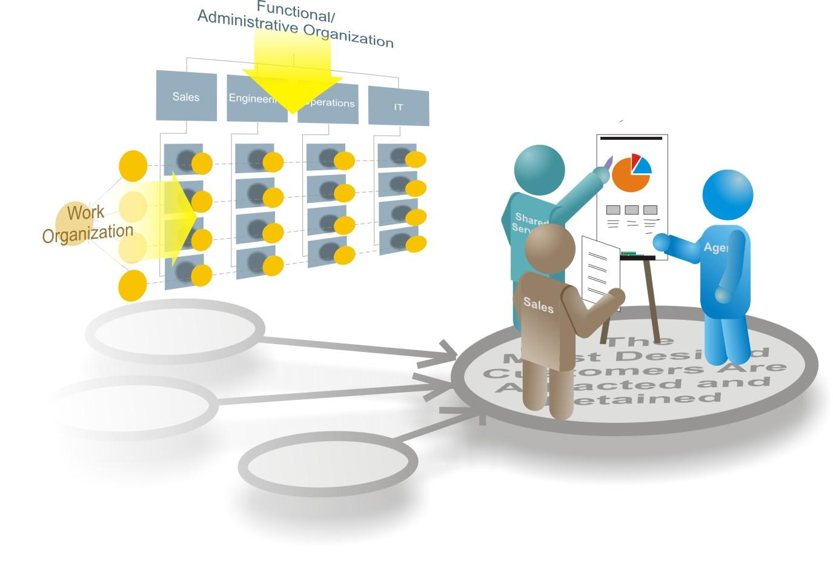

## Pursuing the Right Initiatives

An outcomes-based organization uses their GPS as the ideal framework to manage portfolios of actions and initiatives. Outcomes provide an objective means to test the alignment and contributions of individual projects. Furthermore, aggregating individual outcomes that comprise an affinity group facilitates the management of programs within the overall portfolio.

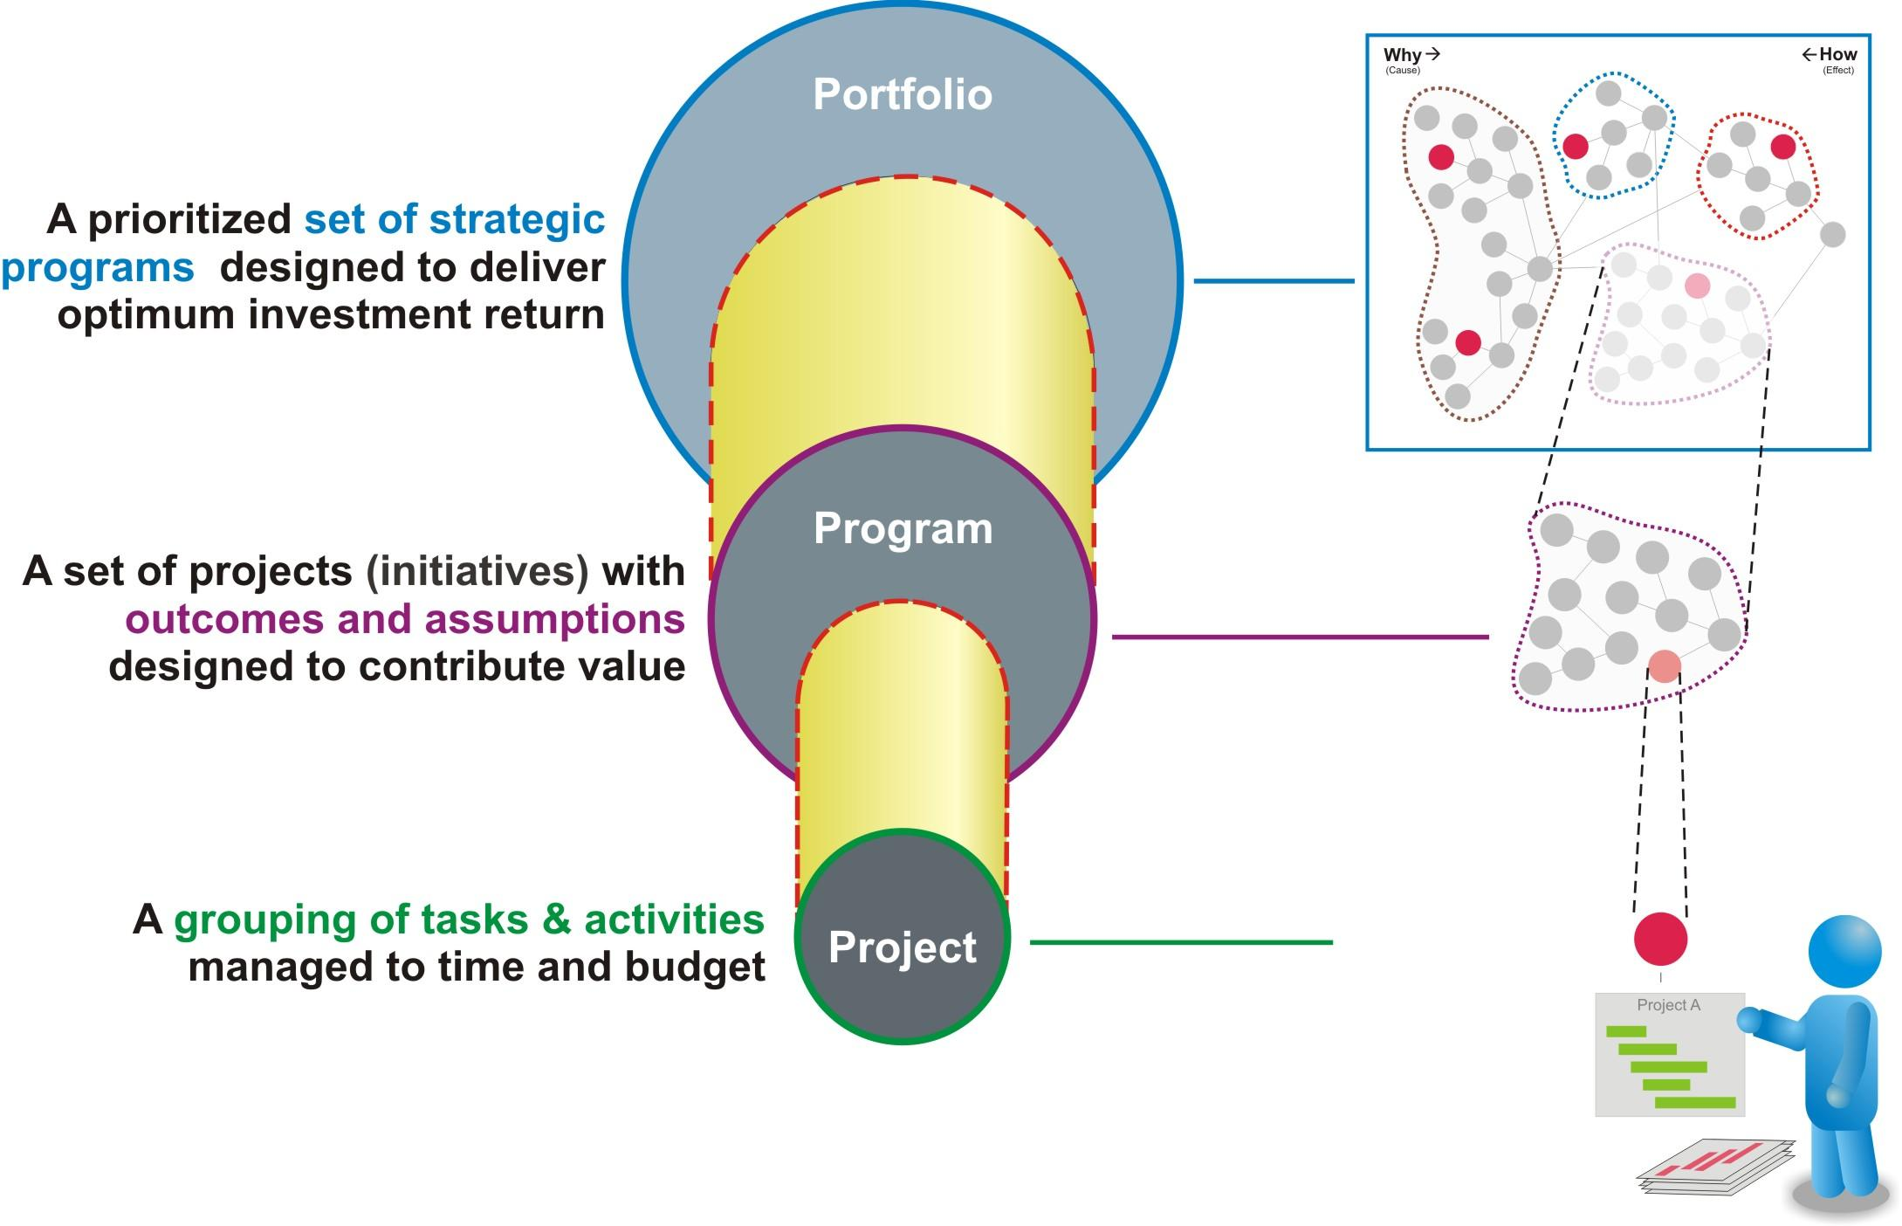

## Having a Clear Line-of-Sight

In an outcomes-based organization a clear line of sight exists between specific tasks through the strategies and vision of the company. Created using the GPS, this line of sight allows each employee to have a clear sense of purpose regarding their role, while they’re engaged in specific initiatives and how they contribute to the overall success of the organization.

This line of sight creates the ability to focus the organization on the right priorities, effectively align the company’s resources and assets to those priorities and link activities to best accomplish the desired actions. All of this ensures the greatest use of the company’s resources and return on their assets and human capital.

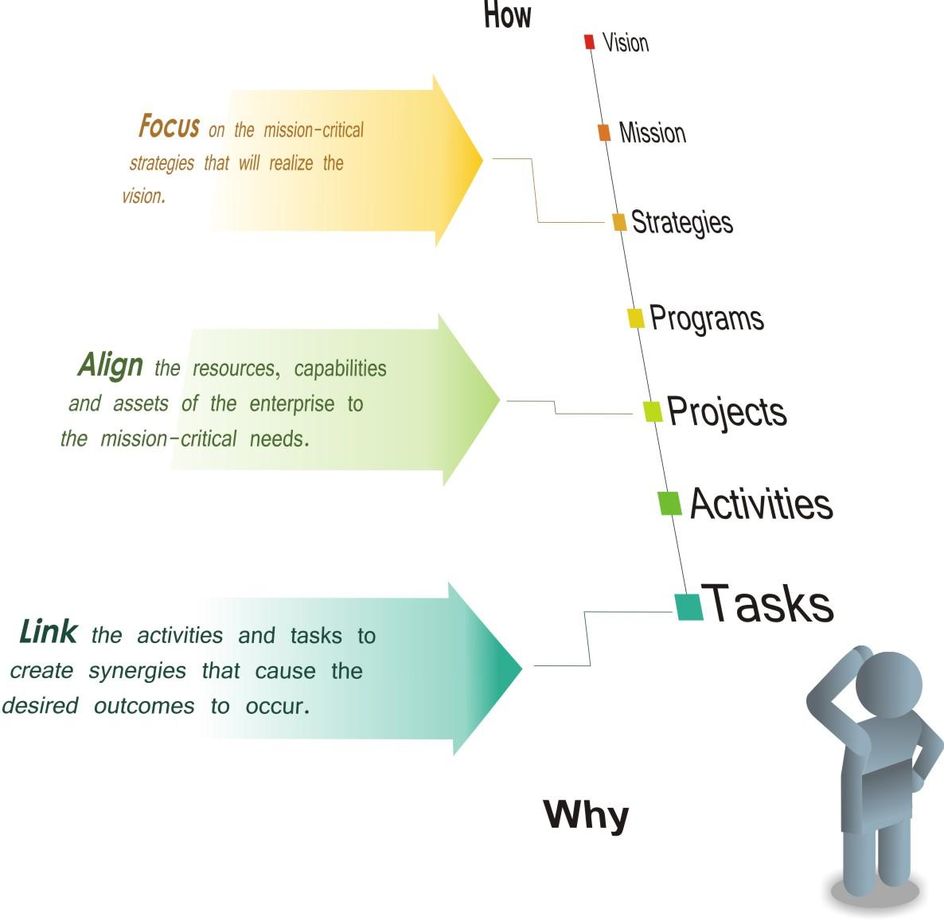

## Developing an Intolerance for Mediocrity

We are prisoners of habit – doing largely what we have always done. For most of us our brains are hardwired. From birth and over the years our perceptions and patterns of thinking have been formed from social, economic and educational experiences. The cultures of organizations envelop us and it doesn’t take long to become the company – doing things that have always been done.

An outcomes-based organization continually challenges convention and habit. In doing this, employees are encouraged to:

* **Think** – To remove the facade of perceptions and habit and discover new opportunities by imagining what is possible. Get as far away from today by working backward from the future.
* **Innovate** – Derail our normal tracks of thought that have been laid over the years through our experiences and accumulated knowledge. Experience and knowledge is a rear-view mirror and has been gained from getting from where we were to where we are today; using too much of it will generate new ideas that are similar to old habits. Instead, ignite the imagination; it’s the only way to get to the future.
* **Change** – It’s far easier to ‘act yourself’ into a new way of thinking than ‘think yourself’ into a new way of acting. Although there are processes, tools and techniques involved, much of becoming an outcomes-based organization involves a fundamental mindset shift. Change is never easy, so don’t over analyze or make something more complicated than it needs to be. Instead pick one opportunity (which is content) and run it though the context of thinking, innovation and change. Start by creating a series of small successes that will generate real and meaningful results. Nothing is better for building excitement and momentum for change.

## Getting to the Roots of Change

Change Management has a relatively brief history. The first change management framework was published in the mid-1980s. Change management as a recognized discipline came into vogue with large IT-based ERP systems of the late 1990’s. These programs have had varied levels of success.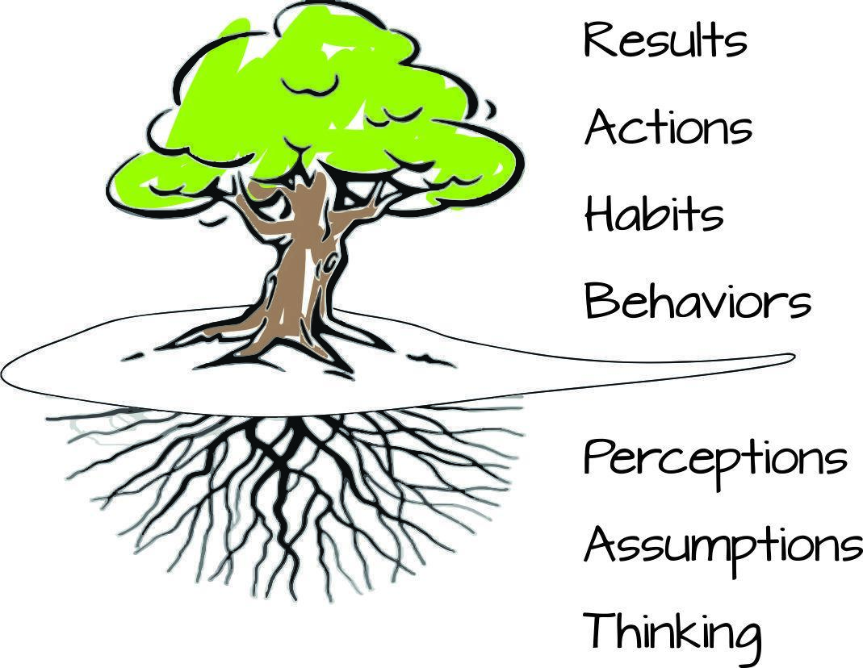

A tree makes an excellent metaphor to explain how people change. With a tree we see what is above the ground’s surface; its leaves, branches and trunk. Trees that shed their leaves give us an indication of the season. The thickness of a tree’s trunk gives us a clue about its age. We see in the turbulent wind of a storm the younger trees more readily flex and bend while the older, established trees are more rigid and steadfast as their deep roots help resist the storm’s wind.

The vibrancy of the tree is dependent on the soil in which it lives. Obviously roots that are in black fertile soil will have a rich source of nutrients allowing the tree to grow strong. The opposite is true if the tree is planted in sandy soil that lacks those nutrients.

Like a tree on the surface we can see a lot about a person too. We can observe the type of results they get from the actions they choose. Through these actions we can see the habits that have formed and behavior they exhibit. And like a tree we see younger individuals being more flexible than older individuals when the winds of change are swirling around them. Finally we see individuals who are starved for nutrients from the environment they work to be weaken while individuals that work in fertile environments are inspired, engaged and enabled to do the extraordinary.

Traditional approaches to change begin with results. When a company is not getting the business results expected they launch and initiative to improve performance. This could be things like an acquisition, new enterprise systems, and lean/six-sigma programs. These actions are going to require the habits and behaviors of people to change; hence a change management program.

Unfortunately, many traditional change programs only provide topical treatment to the challenge. They fall short of affecting meaningful and lasting change to habits and behaviors because they fail to get below the surface to understanding and changing what drive behaviors; perceptions, assumptions and how a person thinks.

Although a lackluster business result (i.e. sales revenue) may still be the trigger, an outcome-based organization begins to foster change by addressing the perceptions, assumptions and manner in which individuals have about sales revenue. In doing this the visible habits, behaviors and consequently the actions of an individual, team and eventually the organization are more effectively changed.